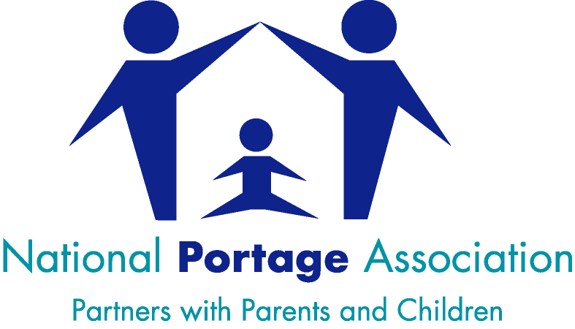
Office Use Only
Date Form received
Number of NPA members
Service Registration No.
Invoice No.
Invoice Date
Date Certificate sent
Date Database Updated
Date Website Updated
Region

APPLICATION FOR PORTAGE SERVICE REGISTRATION or AFFILIATED REGISTRATION
YEAR 2021-2022

IMPORTANT: Service Registration for this year will run from 1st June 2021 to 30th September 2022,
(Service Registration will then become renewable annually, on 1st October)

Please read the Criteria for Service Registration or Affiliated Registration 2021/22 before completing this application (Services not offering Home Visiting can apply for Affiliated Registration.)

Details of Service
Name of Service
Address
Portage Lead/Team Manager *

E-mail
Telephone No.
Contact Person and Job title*
(E.g. Administrator)
Email
(If different from above)
Telephone
(If different from above)
*Team Leader and Contact Person details will be published on our website.

Billing Details
Name of Service
Address
(If different from above)
E-mail
Telephone No.
Purchase order No:

Service Details
Area Served
Local Authority
Service funded by
Age range of children supported

Portage Impact
When is Portage provision available? | Term time only/all year
Has your budget for Portage provision been cut in the last 12 months?  If YES by what proportion | YES / NO
Has your Service been restructured in the last 12 months or is a restructure planned? Brief outline | YES / NO
Are Portage Home Visits still the main service you offer? | YES / NO
Has the number of PHVs in your team changed in the last 12 months? If so How?
How many referrals were made to the service in 2020?
Have referrals increased or decreased from the previous year? | Increased/Decreased
How many referrals are currently on your waiting list?
What is the approximate current length of wait from point of referral?
What is the average length of contact with the service?
Is Portage being used in Early Years Settings in your area? | YES / NO

List of Team Members
Name | Job title | Name | Job title

Do any of the Team Members listed above work part-time hours? | YES/NO
If YES – How many Full-time Equivalents (FTEs) does your whole team equate to?  (This information will be used to confirm the NPA Membership requirements set out in question 8) | No of FTEs

APPLICATION FOR PORTAGE SERVICE REGISTRATION or AFFILIATED REGISTRATION
YEAR 2021-2022

CRITERIA FOR REGISTRATION –
Please answer the following questions., completing the relevant sections for Service Registration or Affiliated Registration*

For guidance, please refer to the relevant criterion detailed in the 2021/22 Service and Affiliated Registration Criteria documents.

*Affiliated Registration can be applied for by Portage Services who do not offer a Home Visiting option (so would not meet the criteria for full Registration)

1.USING PORTAGE PRINCIPLES (All)
Does your service use Portage Principles within their early years practice? YES / NO
2a HOME VISITING ARRANGEMENTS (Service Registration)
Please indicate the frequency of your home visits Weekly/Fortnightly

What other Services do you offer?

Groups |  | Setting Support
Training |  | Parent Support
Early Support |  | Service Support
Other (please give details)

2b OTHER PORTAGE SUPPORT/ACTIVITY (Affiliated Registration)
Explain/provide details about the type of service you offer to families and other providers

3. HOLISTIC ASSESSMENT (All)
Please provide details of the assessment tools you use when working with families. These may include Toolkits, observational records and development profiles/checklists.
ES Developmental Journal |  |  |  |  | Pathways
ES Down Syndrome Journal |  |  |  |  | Portage Developmental Checklist
ES Hearing Impaired Protocol |  |  |  |  | Portage SEND Best Practice Assessment Checklist
ES Visually Impaired Journal |  |  |  |  | Sensory Interactive Profiles
Early Years Foundation Stage |  |  |  |  | Teaching Talking
GEMS |  |  |  |  | Venturing into Play
Kidderminster |  |  |  |  | Other (please give details below)
4a REVIEWING PLANS / GOALS WITH PARENT AND CARERS (Service Registration)
Do you use a Plan, Do, Review system to plan outcomes with parents and carers? YES / NO

Do you carry out reviews at least 3 times a year? YES / NO
4b ASSESSMENT AND REVIEW (Affiliated Registration)
What types of assessment and review do you undertake within your service?
5.SHARED PLANNING AND RECORD KEEPING (All)
Please indicate which of the following you routinely use to plan and share with parents/carers.

Activity Charts/Diaries

Observational Records

Records of Home Visits/Contacts with family
Other (please describe)

6a PORTAGE TRAINING FOR HOME VISITORS (Service Registration)
Have all the Portage Home Visitors successfully completed a Portage Workshop delivered and certificated by an NPA Accredited Trainer? YES / NO

If your Service has new Portage Home Visitors what arrangements have been made for them to attend a Portage Workshop/complete NPA Core Competencies/the PHV Induction Module?

6b PORTAGE TRAINING FOR EARLY YEARS PRACTITIONERS/ADVISORS (Affiliated Registration)
Have all the Early Years Practitioners/Advisors successfully completed a Portage Workshop delivered and certificated by an NPA Accredited Trainer? YES / NO
7a SUPERVISION AND DEVELOPMENT OF PORTAGE HOME VISITORS (Service Registration)
Do your Portage Home Visitors have planned supervision/discussions about individual children’s progress and their own Portage practice with an experienced early years professional at least fortnightly? YES / NO

If YES – are they - INDIVIDUAL / SMALL GROUP or BOTH

If NO - What access arrangements are in place to support Home Visitors working with individual children and families?

Has everyone providing supervision/support to Portage Home Visitors successfully completed a Portage Workshop delivered and certificated by an NPA Accredited Trainer? YES / NO

If NO do they have a good understanding of Portage Home Visiting, the Portage Principles and the NPA Code of Practice?
YES / NO

7b SUPERVISION/QUALITY ASSURANCE OF PORTAGE DELIVERY (Affiliated Registration)
Do your practitioners have planned supervision/discussions about individual children’s progress and
their own Portage practice with an experienced Portage practitioner at least fortnightly? YES / NO

If YES – are they – INDIVIDUAL/SMALL GROUP/BOTH

If NO – please use the space below to describe your Portage supervision arrangements.

8. APPRAISAL ARRANGEMENTS (All)

Does your service use a formal appraisal system to support personal and professional development of your Portage Home Visitors/Early Years Practitioners? YES / NO

If NO what appraisal arrangements are in place?

9. MEMBERSHIP OF THE NATIONAL PORTAGE ASSOCIATION (All)
Please give details of Portage Home Visitors/Early Years Practitioners in your team who hold professional membership of the National Portage Association, giving current Membership Number.
Services must have at least 3 current members of the NPA (professional membership) or for small services of
4 PHVs/EYPs or less, 50% of the team must hold NPA professional membership.
Name | Membership Number |  |  |  | Name |  |  | Membership Number
10. NPA Core Competencies (All)
Do the NPA Core Competencies of Family Partnership; Multi-agency Working; Planning, Recording
and Sharing Activities, Continuing Personal Development and Continuing Professional Development underpin the delivery of your Portage Service YES/NO

The Core Competencies are available to download free from the NPA Website or a hard copy can be ordered from the office at a cost of £5 plus postage.

11. ACCREDITED TRAINER (All)
Please list the name and accreditation number of Accredited Trainers in your service and the name/s of anyone working towards Accredited Trainer Status with the date they attended the NPA TfT course or were accepted as a Trainee on the new Pathway
AT Name |  | Accreditation Number |  |  | Trainee Name |  | Date attended TfT or  Accepted on New Pathway
12. PORTAGE HOME VISITING TEAM or EARLY YEARS PRACTITIONERS QUALIFICATIONS (All)
Please list the members of your team of PHVs/Early Years Practitioners who have passed the Level 3 Open Award, BTEC Level 3 Advanced Award in Portage Skills and/or the BTEC Level 4 Professional Certificate in Portage Practice OR hold a relevant degree/BTEC Level 4 equivalent qualification.
Name |  | BTEC/Open Award  Level 3 Passed |  |  | Name |  | BTEC Level 4 Passed
Name |  |  | Degree or BTEC L4 Equivalent Qualification |  |  | Date of Award

As a Registered Service or Affiliated Service, we undertake to raise awareness of the National Portage Association and promote its values and principles as outlined in the Value Statement.

Declaration [Data Protection] Please tick √ to confirm agreement.
I understand that the information provided above is to be used for the purpose of supplying contact details and general information about the above-named Portage Service.

I confirm that I am happy for the above information to be held and used by the National Portage Association and for the contact details provided to be published.
from the document or the summary of an interesting point. You can position the text box anywhere in the document. Use the Drawing Tools tab to change the formatting of the pull quote text box.]

I certify that to the best of my knowledge the information on this form is correct.

Name: _____________________________________________________________

Position: _________________________________________ Date: _________________

To apply for service or affiliated registration for 2021-2022, please return this form to National Portage Association via email to administrator@portage.org.uk (Email applications are preferred)

OR by post to: National Portage Association, Kings Court, 17 School Road, Hall Green, Birmingham, B28 8JG

Please return applications as close to 1st June 2021 as possible

You will be invoiced when your application for registration has been checked and accepted.

The cost will be £150.00 plus VAT (please note: for 2021/22 ONLY, the period of registration will be from 1st June 2021 to 30th September 2022 – 15 months in total. Registration will then be renewable annually on 1st October)

If payment is not received in accordance with our terms and conditions, an administration charge of £40 will be incurred.

Registration will be effective from 1st June 2021 if payment has been received; terms Net 30 days

