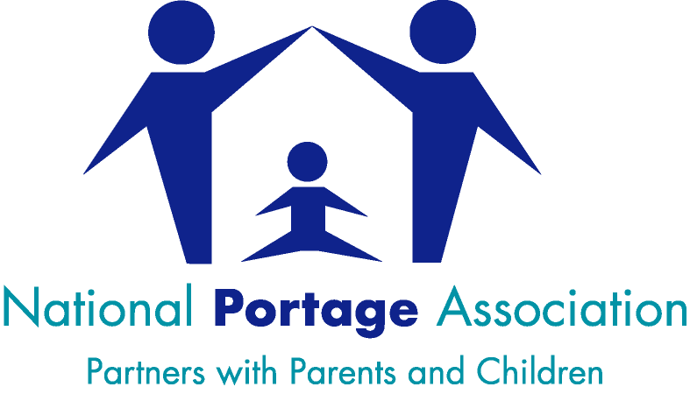

The Portage Workshop – A Small Steps Approach to learning for Children with SEND

- The Portage Workshop is designed to be delivered over two full days plus a Follow-Up Session 1-2 months after the workshop. It is also possible to deliver the workshop over three shorter days plus a Follow-Up Session. Other delivery options may also be possible and should be discussed with the Chair of Training.
- The Follow-Up Session aims to ensure participant’s learning becomes embedded into their day-to-day practice. It is also an opportunity to share information about further NPA support, training and CPD opportunities.
- Participants need to attend all of the workshop days (including the Follow-Up Session) and complete the individual assignment in order to gain the certificate of attendance.
- Completion of the workshop offers the opportunity for the participants to study further in order to gain a Level 3 qualification in Portage.
- Participants who are working in a Portage service will have the opportunity to study further to gain a Portage Home Visitor Certificate. This will be done within their service.
- The Portage Workshop is designed for 24 participants. The number of participants should be no less than 12.

It is the responsibility of the Provider to:
- Print workshop manuals for participants (the workshop materials will be sent to the provider in an ordered pdf format)
- Provide and cover the costs of a venue with seating and tables for participants
- Provide IT facilities for PowerPoint projection and sound
- Manage the booking process for the workshop, produce an attendance register for each day and provide name badges for participants and trainers
- Make arrangements for refreshments for participants and lunch (optional) and liaise with the NPA Accredited Trainer regarding timings

The NPA will:
- Provide at least one NPA Accredited Trainer to deliver the workshop
- Ensure the trainer liaises with the Provider to arrange mutually convenient dates, workshop start/finish times, refreshment and lunch breaks
- Provide an electronic version of the workshop participant’s manual for the Provider
- Advertise the workshop on the NPA website (if required)
- Provide NPA certificates to all who successfully complete the workshop (including the Follow-Up session)

The cost of the Workshop is £6,000. Please note that this is a flat fee – there are no hidden or additional costs. With the recommended number of 24 participants, this equates to a cost of £250 per person.

