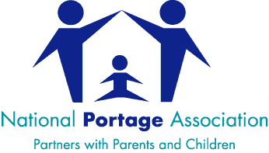
Request for Portage Training
Name of Lead Contact Person within your organisation
Contact Details | Telephone Number:  Email address:
Organisation/EY Provider Name
Organisation/EY Provider Address
Where is the workshop to be held? | Please give details of country/region/local authority/town or city as well as address of training venue if known at this stage
Preferred date(s) | Please note that the NPA require a minimum of 3 months’ notice to organise a workshop
Participants details | Please provide some information about the professional background of the participants who will be attending the training  Anticipated number of participants (approx.):
Which Portage Training Course are you interested in? | Please tick:
Which Portage Training Course are you interested in? | The Portage Workshop
Which Portage Training Course are you interested in? | Portage Awareness Workshop
Which Portage Training Course are you interested in? | International Portage Workshop
Which Portage Training Course are you interested in? | Portage Continuing Professional Development (PCPD)Modules:
Which Portage Training Course are you interested in? | 1. Profound & Multiple Learning Needs
Which Portage Training Course are you interested in? | 2. Behaviour

Please email this completed form to: administrator@portage.org.uk

