**Portage Information for Families**

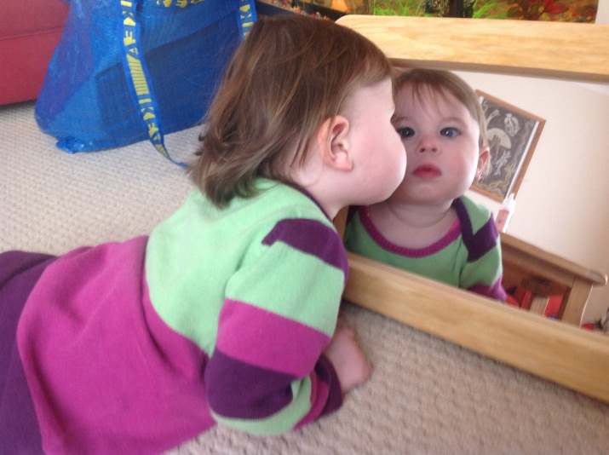Portage is a home-visiting educational service for young children who have special educational and or additional needs.

An Early Years Portage and Inclusion Specialist will come to see you, usually once a week. They will play with your child, talk with you about your child’s development and give you ideas for play/teaching activities that could stimulate your child’s development. You will jointly decide on one or two of these, which you will then carry out with your child during the week.

During the first few visits you and the Portage and Inclusion Specialist will look at your child’s current skills and level of development (for example language skills, motor skills and behaviour). With this as a starting point, goals will be set.

During a visit you and your child will show the Portage and Inclusion Specialist what you have been doing during the past week and discuss this. The Portage and Inclusion Specialist will join in a play session with your child. You can talk about his/her development. You will then decide together which activity you will carry out during the week.

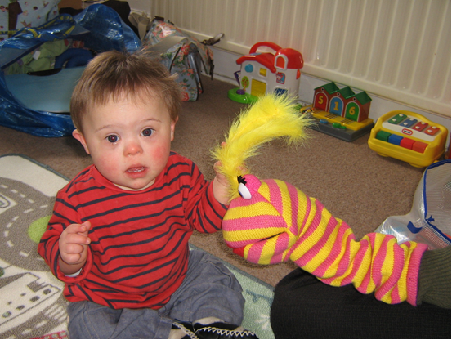

Your child’s development and long term goals will be reviewed and recorded at regular intervals. Weekly activities will be individually designed for your child, aiming not only to be within his/her ability but also to be enjoyable. New skills will be broken down into small steps; this way your child will be continuously building on success.

Contact Details: Early Years Portage and Inclusion Team, Bristol Education Centre, Sheridan Road, Horfield, Bristol BS7 0PU. Telephone: 0117 3773235